Air Cargo Analysis

1)Query to display all the passengers (customers) who have travelled in routes 01 to 25 Take data from

the passengers_on_flights table.

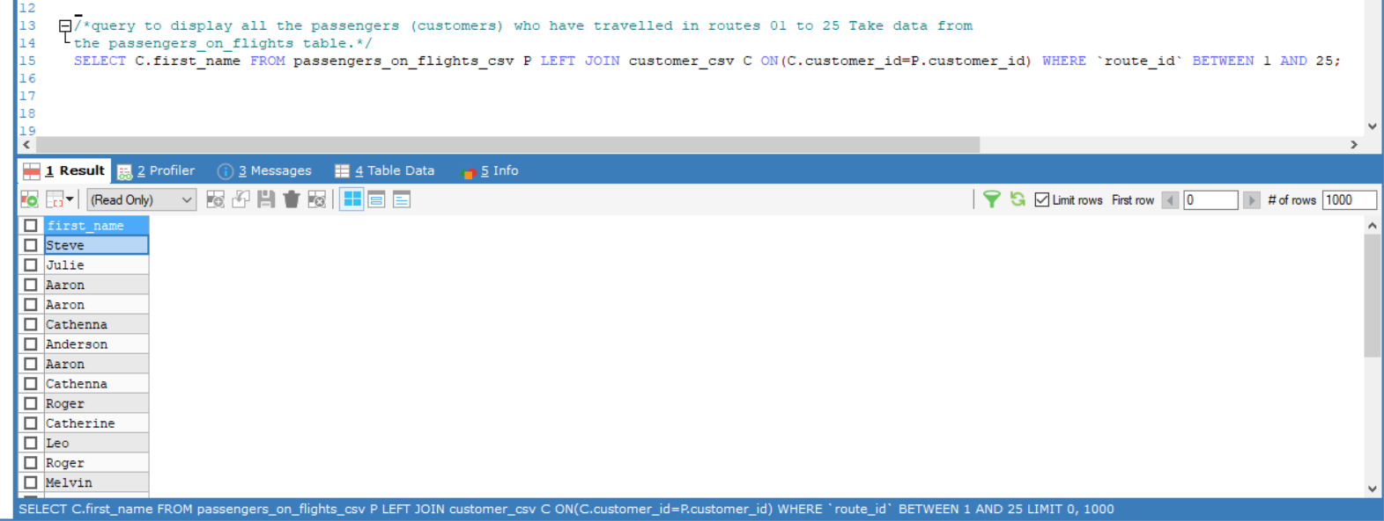

2)Query to identity the number of passengers and total revenue in business class from the ticket_details table

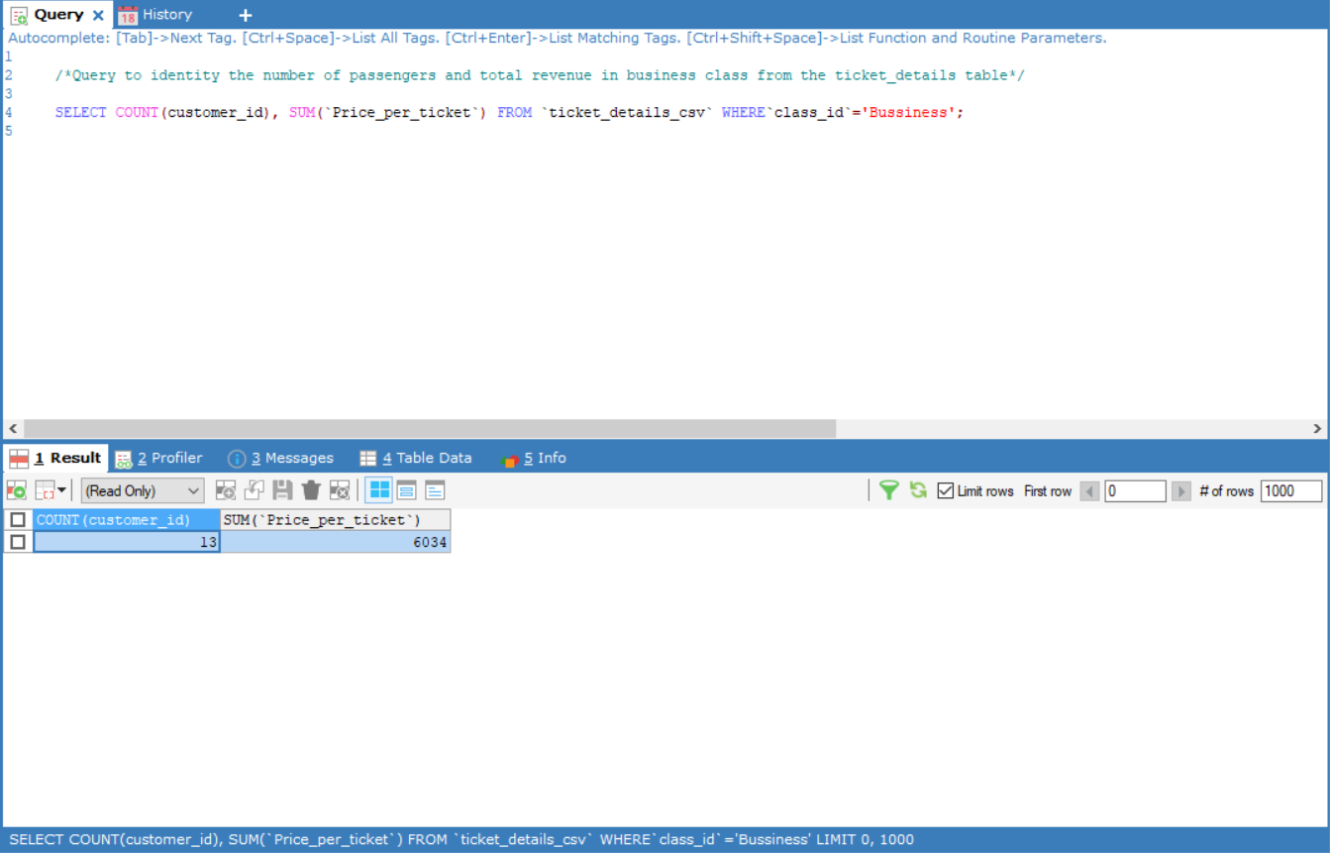

3) Query to display the Full name ot the customer by extracting the first name and last name trom the customer table.

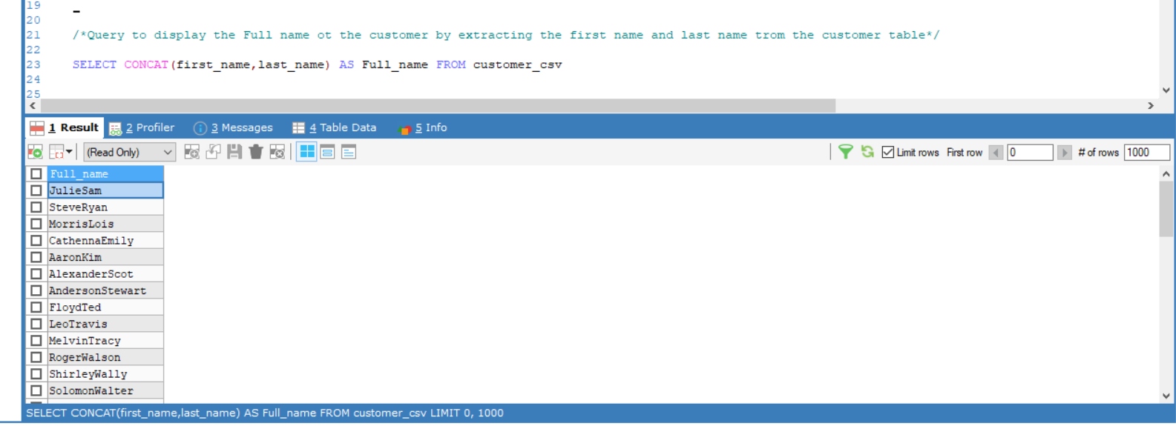

4) Query to extract the customers who have registered ana booked a ticket. use data from the customer and ticket_details tables.

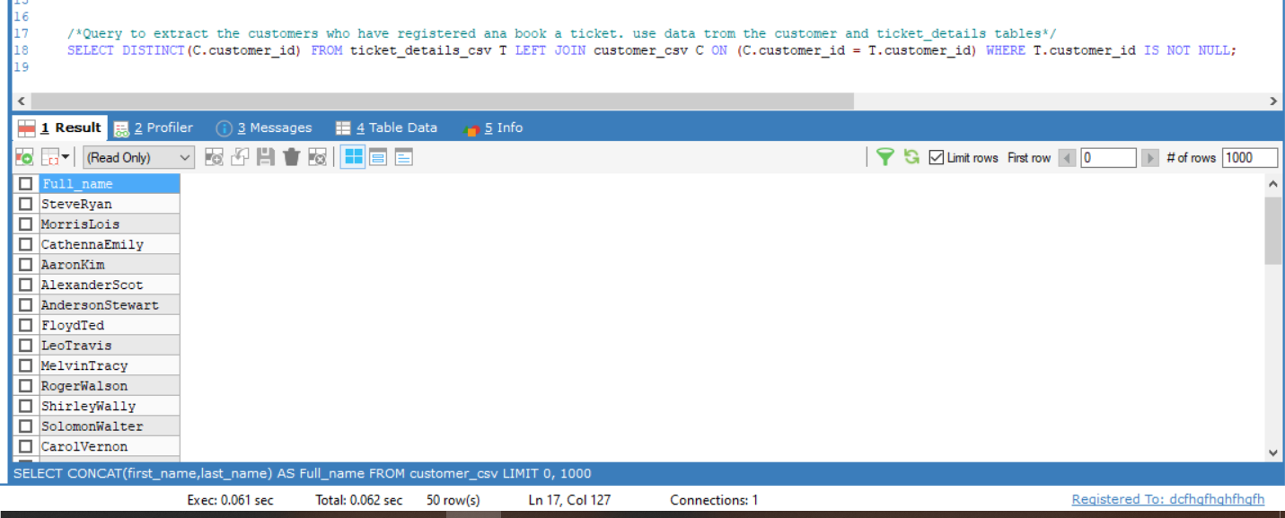

5) Query to identity the customer's first name and last name based on their customer ID and brand (Emirates) from the ticket_details table.

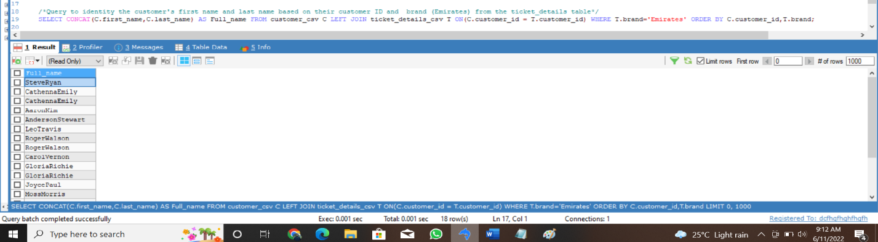

6) Query to identity the customers who have travelled by Economy Plus class using Group By and Having clause on the passenger_on_flight table.

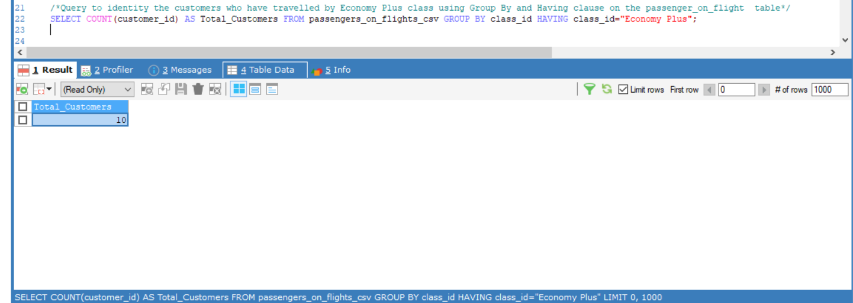

7) Query to identity whether the revenue has crossed 10000 using the IF clause on the ticket_details table

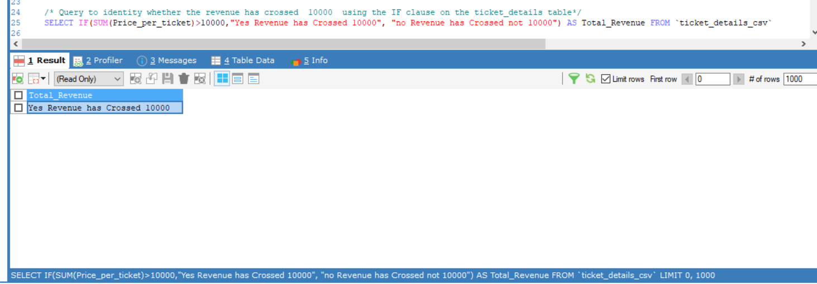

8) Query to create and grant access to a new user to perform operations on a database.

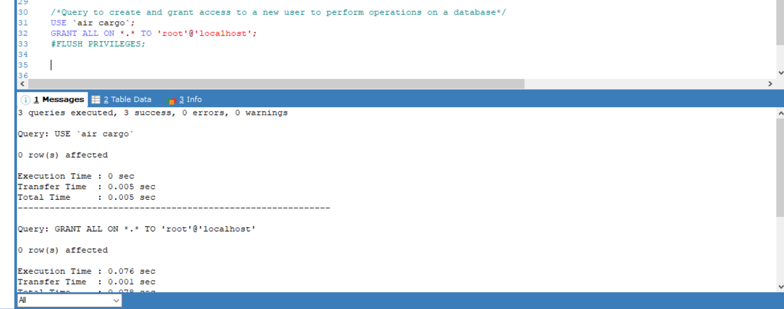

9) Query to find the maximum ticket price for each class using window functions on the ticket_details table.

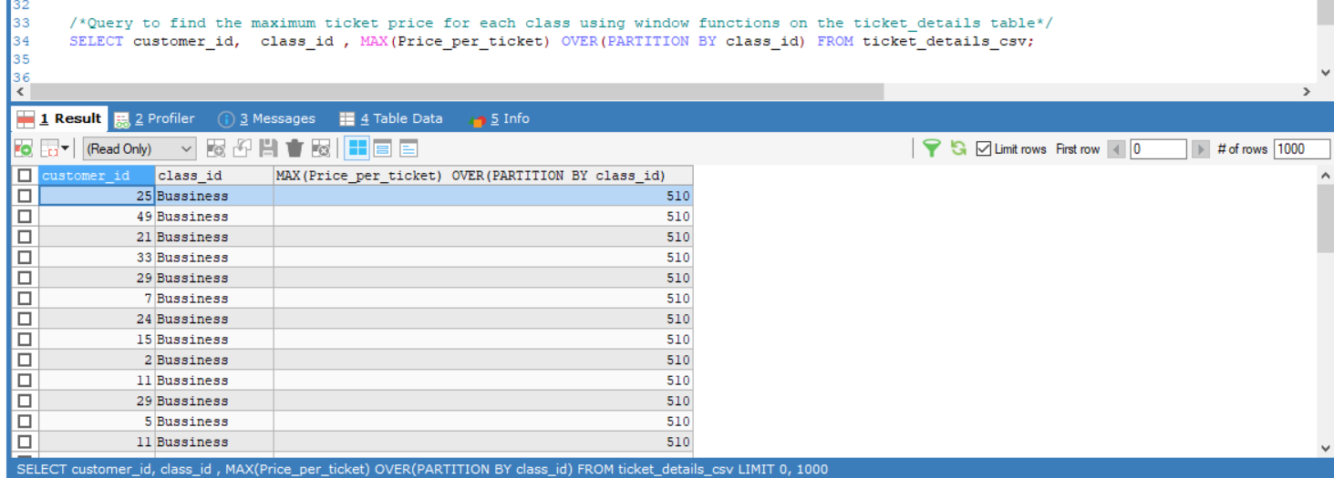

10) Query to extract the passengers whose route ID is 4 by improving the speed and performance of the passengers_on_flight table.

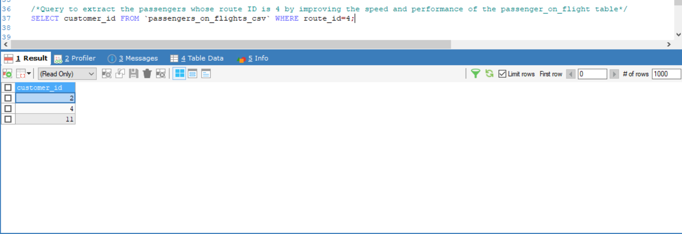

11) For the route ID 4, write a query to view the execution plan of the passengers_on_flight table

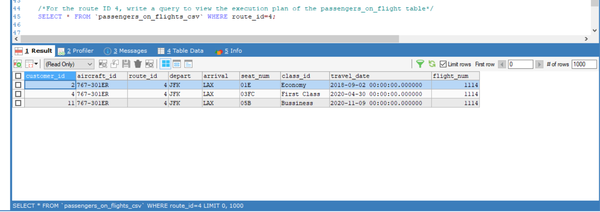

12) A query to calculate the total price of all tickets booked by a customer across different aircraft IDs using rollup function.

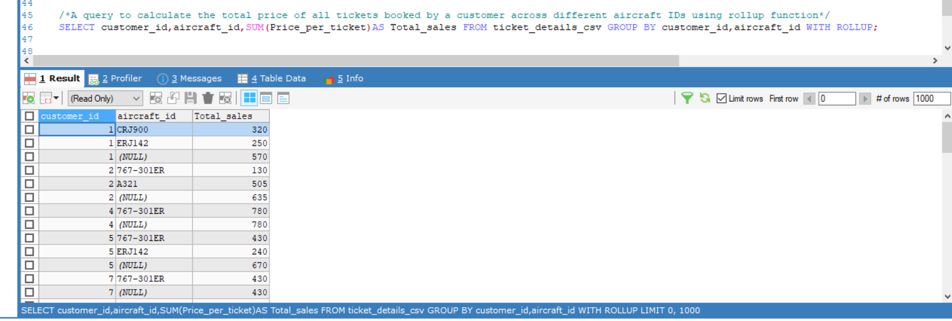

13) Query to create a view with only business class customers along with the brand of airlines.

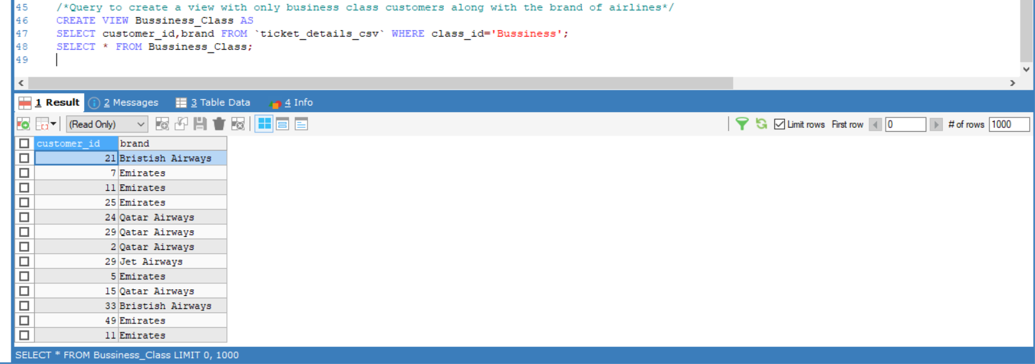

Here, the given data was in Excel, so we imported that to SQL and created a database and analyzed and wrote queries for some of the various specific information from which Air Cargo can get clear insights of their company.